Prepare and File Petition for Probate | 1-2 months
Court hearing on the Petition for Probate | 2-3 months
The following are issued: Letters of Administration/Testamentary, Orders for Probate, and Duties and Liabilities, Issues Bond (if ordered) | 2-4 months (if not contested)
Notice to Creditors | 2-4 months
Inventory and Appraisement | 4-8 months
Pay State and Federal Taxes (if necessary) | 6-12 months
Allow or Reject Creditor Claims
Possible Preliminary Distributions
Notice to Department of Health Services (if deceased received medical)
Notice to the State Tax Board (if heir is out of state)
Claim of Exemption (if assets transfer to a minor) | 6-15 months
Receive Final Tax Letter from State and Federal (if appropriate) | 6-18 months
File Petition for Final Distribution and Accounting | 8-16 months
Hearing on Petition for Final Distribution and Accounting
Order Approving Final Distribution and Accounting
Distribution of Assets to Heirs | 9-17 months
Final Discharge Order (indicates close of probate case) | 9-18 months
Final Distribution of Funds | 9-18 months
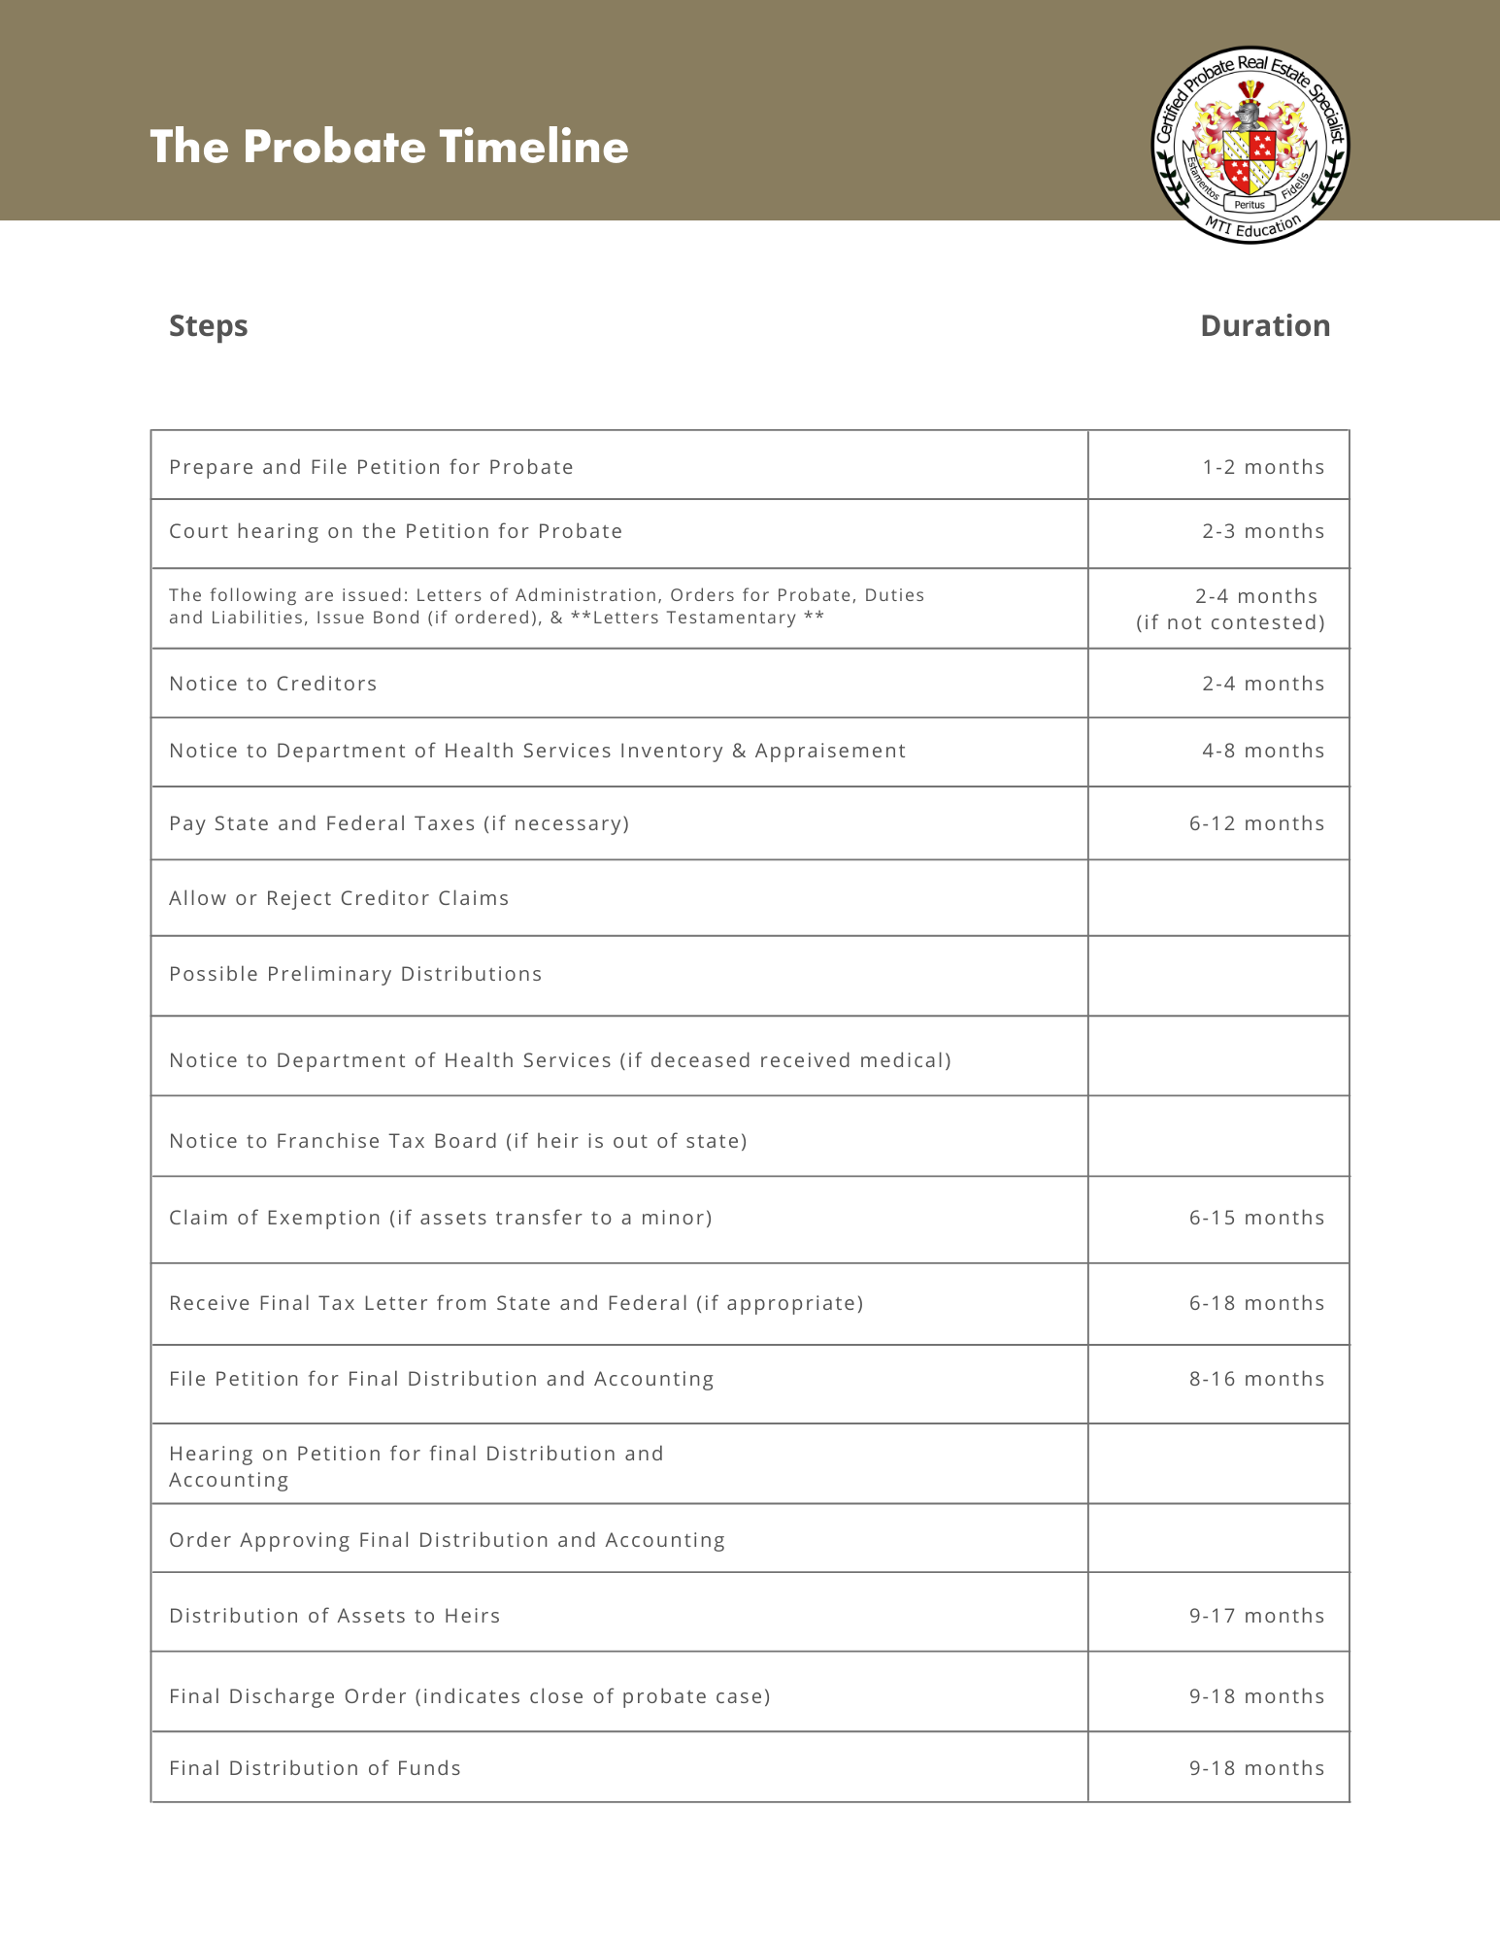

**All information is based on National average

